**OOP Theory Assignment 1**

**Roll No:** 23K-0703

**Section:** BCS-2D

**Question 1:**

You are tasked with designing a platform named Virtual Pet Adoption System where users can adopt and

care for virtual pets with advanced capabilities. The system comprises two essential classes: "Pet" and

"Adopter." Your goal is to implement the system with extended features to enhance user experience and

satisfaction.

Pet Class:

The Pet class represents virtual pets available for adoption. It has following features:

●

●

●

●

healthStatus: A string indicating the health status of the pet (e.g., "Healthy," "Sick").

hungerLevel: An integer representing the pet's hunger level.

happinessLevel: An integer representing the pet's happiness level.

specialSkills: A list containing special skills possessed by the pet.

Implement the following member functions within the Pet class:

●

●

●

●

displayPetDetails(): Displays detailed information about the pet, including happiness level, health

status, hunger level, and special skills.

updateHappiness(): Updates the pet's happiness level based on user interactions.

updateHealth(): Updates the health status of the pet, considering any changes in health.

updateHunger(): Updates the hunger level of the pet, accounting for feeding or other relevant

actions.

Moreover, if a pet is hungry their happiness also decreases by 1 and vice versa. And if you feed it the

happiness increases by 1 upto max 10 happiness.

Adopter Class:

The Adopter class serves as a representation of users who are enthusiastic about adopting virtual pets. In

order to enrich the functionality of this class, you are tasked with incorporating the following features:

adopterName and adopterMobileNum, these attributes should be initialized during the creation of an

Adopter object. A list named adoptedPetRecords within the Adopter class. This list should be responsible

for maintaining detailed records of the adopted pets by the respective adopter.

Implement the following member functions within the Adopter class:

●

●

●

adoptPet(): Allows the adopter to adopt a virtual pet and records its details.

returnPet(): Enables the adopter to return a pet, updating records accordingly.

displayAdoptedPets(): Displays detailed information about all adopted pets, including their species,

happiness, health, hunger, and skills.

Create instances of the extended Pet class, showcasing diverse characteristics and skills for virtual pets.

Instantiate objects of the enhanced Adopter class to represent users interested in adopting virtual pets.

Demonstrate the functionalities of both classes by simulating the adoption, care, and interaction with virtual

pets.

**Code:**

#include <iostream>

using namespace std;

class Pet

{

string healthStatus, species;

int hungerLevel, happinessLevel;

string *specialSkills;

int numSpecialSkills;

public:

Pet() {}

Pet(int hungerLevel, int happinessLevel, string species, int numSpecialSkills)

{

*// Input initial details*

this->hungerLevel = hungerLevel;

this->happinessLevel = happinessLevel;

this->species = species;

updateHealth();

this->numSpecialSkills = numSpecialSkills;

if (this->numSpecialSkills > 0)

{

specialSkills = new string[this->numSpecialSkills];

for (int i = 0; i < this->numSpecialSkills; i++)

{

cout << "Enter Skill " << i + 1 << ": ";

cin >> specialSkills[i];

}

}

}

void updateHappiness()

{

if (hungerLevel > 5)

{

happinessLevel--;

}

else if (hungerLevel < 5)

{

happinessLevel++;

}

*// Putting a cap on the updated values*

if (happinessLevel > 10)

{

happinessLevel = 10;

}

else if (happinessLevel < 1)

{

happinessLevel = 1;

}

}

void updateHealth()

{

if (hungerLevel < 5)

{

healthStatus = "Healthy";

}

else

{

healthStatus = "Sick";

}

}

void updateHunger()

{

string fedData;

fflush(stdin);

cout

<< "Do you want to feed the pet? (Y/n): ";

cin >> fedData;

if (fedData == "Y" || fedData == "y")

{

cout << "[+] Feeding the pet...";

hungerLevel--;

}

else

{

cout << "[+] Not feeding the pet.";

hungerLevel++;

}

*// Putting a cap on the updated values*

if (hungerLevel > 10)

{

hungerLevel = 10;

}

else if (hungerLevel < 1)

{

hungerLevel = 1;

}

}

void displayPetDetails()

{

cout << endl;

cout << "Health Status: " << healthStatus << endl;

cout << "Happiness Level: " << happinessLevel << endl;

cout << "Hunger Level: " << hungerLevel << endl;

if (this->numSpecialSkills > 0)

{

cout << "Special Skills: " << endl;

for (int i = 0; i < this->numSpecialSkills; i++)

{

cout << "Skill " << i + 1 << ": " << specialSkills[i] << endl;

}

}

cout << endl;

}

};

class Adopter

{

string name, mobileNumber;

Pet *adoptedPets;

int numberOfAdoptedPets = 0;

public:

Adopter()

{

cout << "Enter the adopter's name: ";

cin >> name;

cout << "Enter the adopter's mobile number: ";

cin >> mobileNumber;

}

void adoptPet(Pet pet)

{

numberOfAdoptedPets++;

Pet *newAdoptedList = new Pet[numberOfAdoptedPets];

for (int i = 0; i < numberOfAdoptedPets - 1; i++)

{

newAdoptedList[i] = adoptedPets[i];

}

newAdoptedList[numberOfAdoptedPets - 1] = pet;

Pet *temp = adoptedPets;

adoptedPets = newAdoptedList;

newAdoptedList = temp;

if (numberOfAdoptedPets - 1 > 0)

{

delete[] newAdoptedList;

}

}

void returnPet()

{

numberOfAdoptedPets--;

if (numberOfAdoptedPets > 0)

{

Pet *newAdoptedList = new Pet[numberOfAdoptedPets];

for (int i = 0; i < numberOfAdoptedPets; i++)

{

newAdoptedList[i] = adoptedPets[i];

}

Pet *temp = adoptedPets;

adoptedPets = newAdoptedList;

newAdoptedList = temp;

delete[] newAdoptedList;

}

else

{

delete[] adoptedPets;

}

}

void displayAdoptedPets()

{

for (int i = 0; i < this->numberOfAdoptedPets; i++)

{

adoptedPets[i].displayPetDetails();

}

}

};

int main()

{

*// Name Header*

cout << "Student ID: 23K0703" << endl;

cout << "Name: Sarim Ahmed" << endl

<< endl;

cout << "[+] Demostrating the pet class..." << endl;

int happinessLevel, hungerLevel, numSpecialSkills;

string species;

*// Initializing pet one object*

cout << "Enter happiness level for myPet1: ";

cin >> happinessLevel;

cout << "Enter hunger level for myPet1: ";

cin >> hungerLevel;

cout << "Enter species for myPet1: ";

cin >> species;

cout << "Enter number of myPet1's special skills: ";

cin >> numSpecialSkills;

Pet myPet1(hungerLevel, happinessLevel, species, numSpecialSkills);

myPet1.displayPetDetails();

*// Initializing pet one object*

cout << "Enter happiness level for myPet2: ";

cin >> happinessLevel;

cout << "Enter hunger level for myPet2: ";

cin >> hungerLevel;

cout << "Enter species for myPet2: ";

cin >> species;

cout << "Enter number of myPet2's special skills: ";

cin >> numSpecialSkills;

Pet myPet2(hungerLevel, happinessLevel, species, numSpecialSkills);

myPet2.displayPetDetails();

myPet1.updateHunger();

myPet1.updateHealth();

myPet1.updateHappiness();

myPet1.displayPetDetails();

myPet1.updateHunger();

myPet1.updateHealth();

myPet1.updateHappiness();

myPet1.displayPetDetails();

myPet1.updateHunger();

myPet1.updateHealth();

myPet1.updateHappiness();

myPet1.displayPetDetails();

cout << "[+] Demostrating the adopter class..." << endl;

Adopter adopter;

cout << "\n[+] Adopting myPet1";

adopter.adoptPet(myPet1);

cout << "\n[+] Adopting myPet2";

adopter.adoptPet(myPet2);

cout << "\n[+] Displaying Adopted Pets";

adopter.displayAdoptedPets();

cout << "\n[+] Returning Last Pet";

adopter.returnPet();

cout << "\n[+] Displaying Adopted Pets";

adopter.displayAdoptedPets();

}

**Output:**

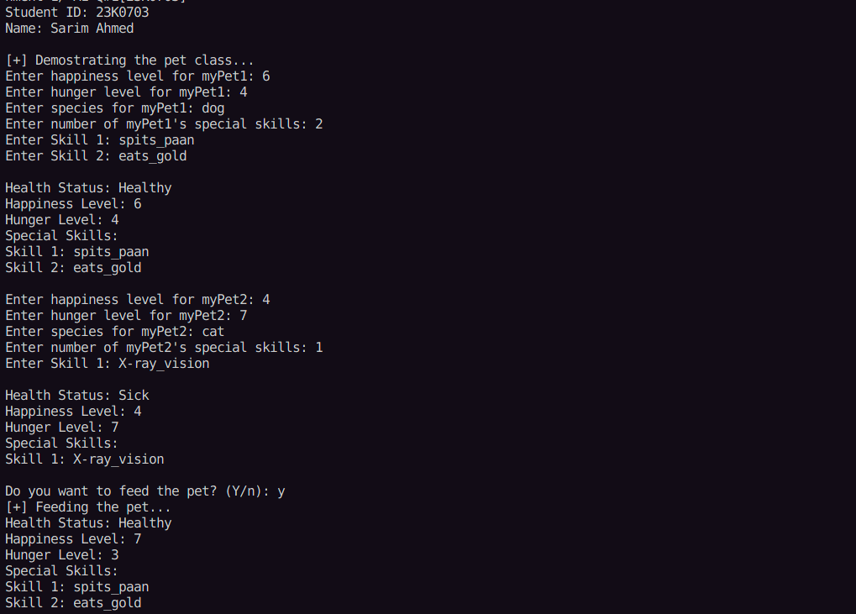

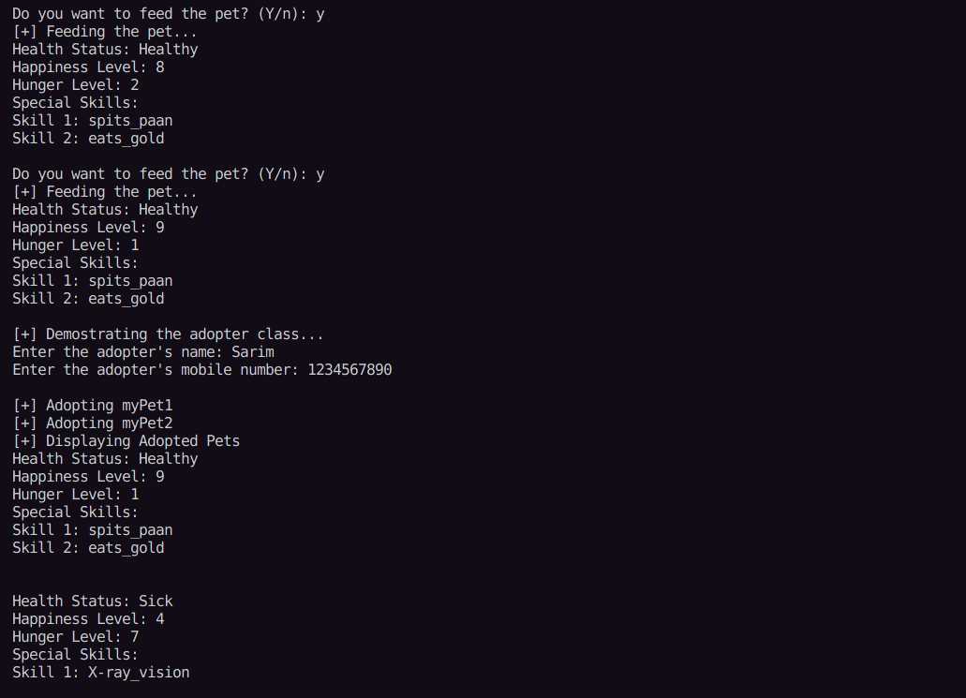

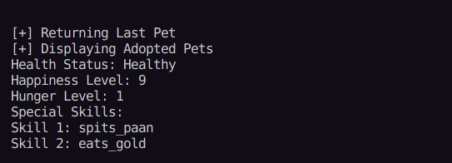

**Question 2:**

Scenario 2:

You’re bored!

You’re looking at the students going in and out of the seating at the dhaba at FAST. You decide to think of

it as an OOP Scenario! You’re looking at the group of students arriving at the tables outside of the dhaba,

and making mental note of how long each group of student stays at a table. For the above scenario, let’s

write a program about the tables at the dhaba.

1. Each table has some properties:

●

●

●

●

Total available seats per table (A table can only have 4 or 8 seats)

Seats currently occupied at a table (assume only one person can occupy one seat)

Free seats at a table

Clean (Boolean flag representing the cleanliness of the table)

2. Each table can have some functionality associated with them:

●

●

●

●

●

●

●

●

A default constructor – which should set the default table capacity to 4. Initially, a table will be

clean and no one will be seated on it.

A parameterized constructor – which should set the capacity to the capacity sent as parameter. If

the number is not 4 or 8, it should be rounded to 4 or 8 (whichever is closest).

Initially, a table will be clean and no one will be seated on it.

Encapsulate the parameters of your class properly. The capacity should not be editable once it has

been set by the constructor.

A table can be used by a group of friends – In order for the table to be used, the table must first be

clean. Whenever a group of friends is using the table, they will decide to use the table that can fit a

group of that size. (A group of 4 will be seated at a table with 4 seats, meanwhile a group of 6 will

be seated at a table with 8 seats).

People can have lunch on the table – once the lunch is finished, the table will no longer be clean.

People can leave the table with or without having lunch.

Someone can clean the table – the table can only be cleaned when no one is seated at the table.

3. Create a global function called “OccupyTable” that accepts a Table array and size of the group of friends.

It should find a table that is not occupied and assign a table to those people. It should mention which table

has been assigned the group, and the seating capacity of the table.

4. Create a global function called “EmptyTable” that accepts a table number and sets it to empty. This

should make proper changes to the variables present within that table object.

5. In your main function, you are required to perform the following actions with your Table class:

●

●

●

Create an array of 5 tables.

○ Two tables should be of capacity 8, and 3 should be of capacity 4.

Call the function OccupyTable and pass the array and 4 as its parameters. (Assume this is table 1)

Call the function OccupyTable and pass the array and 6 as its parameters. (Assume this is table 2)●

●

For table 1, call the functions for:

○ Using the table

○ Having lunch on the table

○ Leaving the table

○ Cleaning the table

Call the function EmptyTable and pass the index of table 2 as its parameter.

**Code:**

#include <iostream>

#include <cmath>

using namespace std;

class Table

{

int totalSeats;

int occupiedSeats;

int freeSeats;

bool clean;

public:

Table()

{

totalSeats = 4;

occupiedSeats = 0;

freeSeats = totalSeats - occupiedSeats;

clean = true;

}

Table(int totalSeats)

{

*// Setting total seats to either 4 or 8*

float x = (float)totalSeats / 4;

int y = (int)round(x);

this->totalSeats = y * 4;

if (this->totalSeats > 8)

{

this->totalSeats = 8;

}

else if (this->totalSeats < 4)

{

this->totalSeats = 4;

}

*// Setting other paramenters accordingly*

occupiedSeats = 0;

freeSeats = this->totalSeats - occupiedSeats;

clean = true;

}

int getFreeSeats()

{

return this->freeSeats;

}

void setOccupiedSeats(int newOccupiedSeats)

{

this->occupiedSeats = newOccupiedSeats;

this->freeSeats = this->totalSeats - this->occupiedSeats;

}

int getTotalSeats()

{

return this->totalSeats;

}

bool getCleanStatus()

{

return clean;

}

void HaveLunch()

{

clean = false;

}

void CleanTable()

{

clean = true;

}

};

void EmptyTable(int index, Table tableArray[])

{

tableArray[index].setOccupiedSeats(0);

cout << "\n[+] Emptied Table#" << index << ".";

}

int OccupyTable(int numOfFriends, Table tableArray[], int totalTables)

{

*// Checking for a suitable table*

for (int i = 0; i < totalTables; i++)

{

if (tableArray[i].getFreeSeats() >= numOfFriends)

{

if (tableArray[i].getCleanStatus())

{

*// Occupy the table*

tableArray[i].setOccupiedSeats(numOfFriends);

cout << "\n[+] Table#" << i << " assigned with " << tableArray[i].getTotalSeats() << " seats.";

return i;

}

}

}

cout << "\n[+] No free table to assign.";

return -1;

}

int main()

{

cout << "\n\nStudent ID: 23K0703" << endl;

cout << "Name: Sarim Ahmed" << endl

<< endl;

Table tableList[5] = {

Table(4),

Table(4),

Table(4),

Table(8),

Table(8),

};

int table1Index = OccupyTable(4, tableList, 5);

int table2Index = OccupyTable(6, tableList, 5);

*// Having Lunch*

tableList[table1Index].HaveLunch();

*// Leaving the table*

EmptyTable(table1Index, tableList);

*// Clean the table*

tableList[table1Index].CleanTable();

EmptyTable(table2Index, tableList);

}

**Output:**

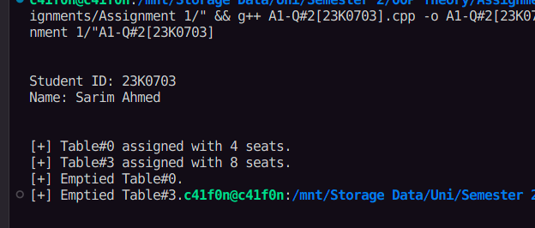

**Question 3:**

Assume we’re writing a very bare bones program to figure out how we can apply OOP to Chess. Let’s

consider the following classes that will be interacting with each other to play the game.

The ChessPiece class is used for all chess pieces (pawn, rook, knight, etc.). Each piece has attributes such

as name(King, Queen, etc.), color (black or white) and a unique symbol (K/k-for king, Q/q-for queen, N/n-

for knight, etc.) to represent it on the board. Other requirements are as follows:

•

•

•

Default Constructor: Whenever this constructor is called, it will create a white pawn.

Parameterized Constructor: Creates a ChessPiece of the type specified by the parameters.

Appropriate getters and setters for your member variables.

The ChessBoard class represents the chessboard itself. It contains a 2D array of ChessPiece to represent

the 8x8 grid. Each element of the array holds a pointer to a ChessPiece object or is set to null if there is no

piece at that position. The class has methods like display() to print the current state of the board, and aother

method, movePiece(), which is responsible for moving a piece from one position to another.

More details about the functions is given below:

•

•

Default Constructor for the ChessBoard class should initialize the 2D array of chess pieces to an initial

game state (also shown below).

The display() method should generate an output like this:

abcdefgh8RNBQKBNR8

7PPPPPPPP7

6........6

5........5

4........4

3........3

2pppppppp2

1rnbqkbnr1

abcdefgh

White pieces can be represented by small alphabet while black pieces can be capital alphabets.

Note: R: Rook, N: Knight, B: Bishop, Q: Queen, K: King, P: Pawn•

The bool movePiece(string source, string destination) method is used to move the chess piece from

a source to destination. It returns true or false based on whether the move is valid or not. For simplicity’s

sake, let only consider the movements for knight and pawns on the first turn.

Example: Function is called as: movePiece(“b8”, “a6”), so this means we are moving the knight from

b8 to a6, which is a valid first move, so your function should return true. Similarly, if the function is

called as: movePiece(“b8”, “d7”), it should return false, as d7 is already occupied by a pawn.

Notes:

The knight moves in an "L" shape on the chessboard. It can move two squares in one direction (either

horizontally or vertically) and then one square in a perpendicular direction. Alternatively, it can move two

squares in a perpendicular direction and then one square in the original direction.

Meanwhile, during the first move only, a pawn has two possible moves: it can move forward by one or two

steps, only if there is nothing in its path.

Please see the diagrams below for further clarification.

**Code:**

#include <iostream>

#include <cmath>

using namespace std;

class ChessPiece

{

string name;

string color;

char symbol;

public:

ChessPiece()

{

color = "white";

name = "pawn";

symbol = 'p';

}

ChessPiece(string color, string name, char symbol)

{

this->color = color;

this->name = name;

this->symbol = symbol;

}

string getColor()

{

return color;

}

void setColor(string color)

{

if (color == "white" || color == "black")

{

this->color = color;

}

}

string getName()

{

return name;

}

void setName(string name)

{

this->name = name;

}

char getSymbol()

{

return symbol;

}

void setSymbol(char symbol)

{

this->symbol = symbol;

}

};

class ChessBoard

{

ChessPiece ***board;

public:

ChessBoard()

{

*// Setting up the board structure*

board = new ChessPiece **[8];

for (int i = 0; i < 8; i++)

{

board[i] = new ChessPiece *[8];

for (int j = 0; j < 8; j++)

{

board[i][j] = nullptr;

}

}

*// Setting up pieces on inital positions*

*// Row 8*

board[7][0] = new ChessPiece("black", "Rook", 'R');

board[7][1] = new ChessPiece("black", "Knight", 'N');

board[7][2] = new ChessPiece("black", "Bishop", 'B');

board[7][3] = new ChessPiece("black", "Queen", 'Q');

board[7][4] = new ChessPiece("black", "King", 'K');

board[7][5] = new ChessPiece("black", "Bishop", 'B');

board[7][6] = new ChessPiece("black", "Knight", 'N');

board[7][7] = new ChessPiece("black", "Rook", 'R');

*// Row 7*

board[6][0] = new ChessPiece("black", "Pawn", 'P');

board[6][1] = new ChessPiece("black", "Pawn", 'P');

board[6][2] = new ChessPiece("black", "Pawn", 'P');

board[6][3] = new ChessPiece("black", "Pawn", 'P');

board[6][4] = new ChessPiece("black", "Pawn", 'P');

board[6][5] = new ChessPiece("black", "Pawn", 'P');

board[6][6] = new ChessPiece("black", "Pawn", 'P');

board[6][7] = new ChessPiece("black", "Pawn", 'P');

*// Row 2*

board[1][0] = new ChessPiece();

board[1][1] = new ChessPiece();

board[1][2] = new ChessPiece();

board[1][3] = new ChessPiece();

board[1][4] = new ChessPiece();

board[1][5] = new ChessPiece();

board[1][6] = new ChessPiece();

board[1][7] = new ChessPiece();

*// Row 1*

board[0][0] = new ChessPiece("white", "Rook", 'r');

board[0][1] = new ChessPiece("white", "Knight", 'n');

board[0][2] = new ChessPiece("white", "Bishop", 'b');

board[0][4] = new ChessPiece("white", "King", 'k');

board[0][3] = new ChessPiece("white", "Queen", 'q');

board[0][5] = new ChessPiece("white", "Bishop", 'b');

board[0][6] = new ChessPiece("white", "Knight", 'n');

board[0][7] = new ChessPiece("white", "Rook", 'r');

}

bool movePiece(string source, string destination)

{

*// calculate position indexes*

char colAlphSrc = source[0];

char rowNumSrc = source[1];

char colAlphDst = destination[0];

char rowNumDst = destination[1];

*// convert alphabet colNum to array index*

int colIndexSrc = colAlphSrc - 'a';

int colIndexDst = colAlphDst - 'a';

*// convert number rowNumSrc to array's index*

int rowIndexSrc = (rowNumSrc - '0') - 1;

int rowIndexDst = (rowNumDst - '0') - 1;

*// Check if source and destination are within bounds*

if (rowIndexDst > 8 || rowIndexDst < 0 || rowIndexSrc > 8 || rowIndexSrc < 0 || colIndexDst > 8 || colIndexDst < 0 || colIndexSrc > 8 || colIndexSrc < 0)

{

return false;

}

*// Check if space is available on the destination and source has a piece*

if (board[rowIndexSrc][colIndexSrc] == nullptr || board[rowIndexDst][colIndexDst] != nullptr)

{

return false;

}

*// Knights*

if ((*board[rowIndexSrc][colIndexSrc]).getName() == "Knight")

{

*// Calculating vertical and horizontal distances*

int deltaHorizontal = abs(rowIndexSrc - rowIndexDst);

int deltaVertical = abs(colIndexSrc - colIndexDst);

*// either verical distance should be 2 and the horizontal 1, or vice versa,*

*// both cannot be the same, or any other number*

if (!((deltaHorizontal == 2 || deltaHorizontal == 1) && (deltaVertical == 2 || deltaVertical == 1)) && (deltaHorizontal != deltaVertical))

{

return false;

}

*// if no checks are triggered, initiate the move*

*// Assigning the source piece to destination, and clearing the source piece*

board[rowIndexDst][colIndexDst] = board[rowIndexSrc][colIndexSrc];

board[rowIndexSrc][colIndexSrc] = nullptr;

return true;

}

*// Black Pawns*

if ((*board[rowIndexSrc][colIndexSrc]).getSymbol() == 'P')

{

*// Calculating vertical and horizontal distances*

int deltaHorizontal = rowIndexDst - rowIndexSrc;

int deltaVertical = colIndexDst - colIndexSrc;

*// horizontal distance should be 0, vertical distance should be -1 or -2, if the row is 7*

*// Check if initial position*

if (rowIndexSrc == 6)

{

if (!(deltaVertical == 0 && (deltaHorizontal == -2 || deltaHorizontal == -1)))

{

return false;

}

}

else

{

if (!(deltaVertical == 0 && deltaHorizontal == -1))

{

return false;

}

}

*// if no checks are triggered, initiate the move*

*// Assigning the source piece to destination, and clearing the source piece*

board[rowIndexDst][colIndexDst] = board[rowIndexSrc][colIndexSrc];

board[rowIndexSrc][colIndexSrc] = nullptr;

return true;

}

*// White Pawns*

if ((*board[rowIndexSrc][colIndexSrc]).getSymbol() == 'p')

{

*// Calculating vertical and horizontal distances*

int deltaHorizontal = rowIndexDst - rowIndexSrc;

int deltaVertical = colIndexDst - colIndexSrc;

*// horizontal distance should be 0, vertical distance should be 1 or 2, if the row is 2*

*// Check if initial position*

if (rowIndexSrc == 1)

{

if (!(deltaVertical == 0 && (deltaHorizontal == 2 || deltaHorizontal == 1)))

{

return false;

}

}

else

{

if (!(deltaVertical == 0 && deltaHorizontal == -1))

{

return false;

}

}

*// if no checks are triggered, initiate the move*

*// Assigning the source piece to destination, and clearing the source piece*

board[rowIndexDst][colIndexDst] = board[rowIndexSrc][colIndexSrc];

board[rowIndexSrc][colIndexSrc] = nullptr;

return true;

}

return false;

}

void display()

{

cout << " \ta\tb\tc\td\te\tf\tg\th" << endl

<< endl;

for (int i = 0; i < 8; i++)

{

cout << 8 - i;

*// Draw Row*

for (int j = 0; j < 8; j++)

{

char symbol;

if (board[7 - i][j] != nullptr)

{

symbol = (*board[7 - i][j]).getSymbol();

}

else

{

symbol = '.';

}

cout

<< "\t" << symbol;

}

cout << "\t" << 8 - i << endl

<< endl;

}

cout << " \ta\tb\tc\td\te\tf\tg\th" << endl

<< endl;

}

};

int main()

{

*// Header*

cout << "\n\nStudent ID: 23K0703" << endl;

cout << "Name: Sarim Ahmed" << endl

<< endl;

ChessBoard chessBoard;

chessBoard.display();

*// Moving Knight*

if (chessBoard.movePiece("g1", "h3"))

{

cout << "Valid Move" << endl;

}

else

{

cout << "Invalid Move" << endl;

};

chessBoard.display();

*// Moving Pawn*

if (chessBoard.movePiece("a2", "a4"))

{

cout << "Valid Move" << endl;

}

else

{

cout << "Invalid Move" << endl;

};

chessBoard.display();

*// Moving Pawn again*

if (chessBoard.movePiece("a4", "a6"))

{

cout << "Valid Move" << endl;

}

else

{

cout << "Invalid Move" << endl;

};

chessBoard.display();

}

**Output:**

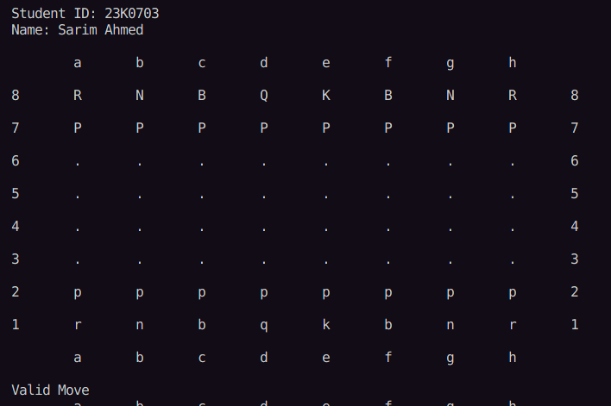

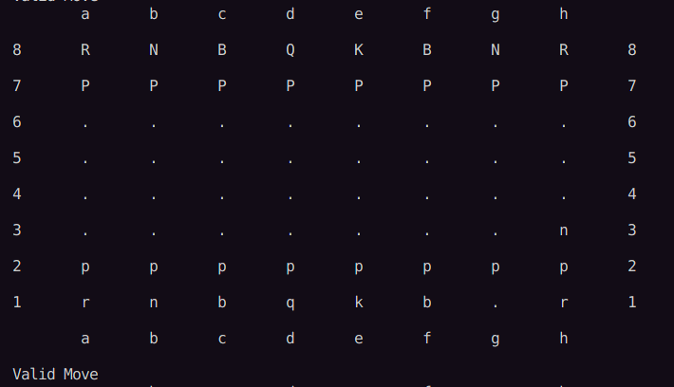

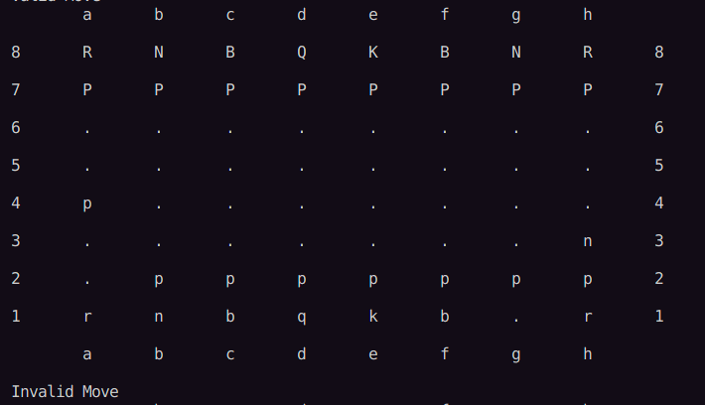

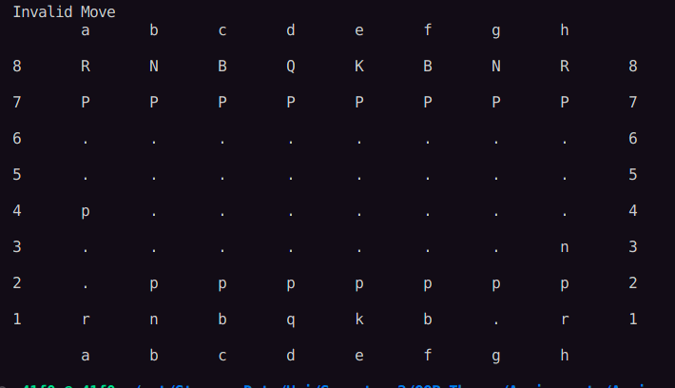

**Question 4:**

You’re being hired to write an application for different rides in a Theme Park. You’re working on the Roller

Coaster(woohoo!!). The Theme Park has provided you with the relevant attributes for your Roller Coaster

class, and they are as follows:

●

●

●

●

●

●

●

Name (of the attraction- some creative name)

Height (maximum height that the roller coaster can reach)

Length (total length of the roller coaster track)

Speed (of the roller coaster)

Capacity (amount of people that can be seated at once)

CurrentNumRiders (number of passengers/riders currently seated in the roller coaster)

RideInProgress (a Boolean flag, depicting whether the ride is currently in progress or not)

For the functionality, they have provided the following information:

●

●

Constructors:

Default – Should set the name to “roller coaster”, height to 500 meters, length to 2000 meters, and

capacity to 20 people. The ride should not be in progress by default.●

●

●

●

●

●

●

●

Parameterized – Should set the values as provided by the user. However, it should not accept a

Boolean to change the ride in progress flag. It should also verify if the capacity of people is in

multiples of two or three, if it is not a multiple of two or three, it should roundit to the closest

multiple of two. In addition to that, the capacity should always be greater than 3.

Appropriate Getter and Setter functions for the available variables. The same checks should be

applied for the capacity variable, as applied in the parameterized constructor.

A function to load/seat the riders into the roller coaster – Passengers/Riders can only be seated into

the roller coaster if the ride is not in progress, and if there is sufficient space for all the riders.In

case there is an excess number of riders compared to the available spaces, it should return the

number of riders that were not seated successfully, otherwise it should return 0.

A function to start the ride – This function can only be called if a ride is not in progress, if a ride is

in progress, it should return -1. If a ride is not in progress, it needs to verify that all the seats have

been occupied by the riders. In case all the seats are not occupied, it should return the number of

empty seats.

A function to stop the ride – This function can only be called if a ride is in progress. This will stop

the ride.

A function to unload the riders from the roller coaster – Passengers/Riders can only be unloaded

from the roller coaster if they ride is not in progress.

A function to accelerate the roller coaster – Every time this function is called, it should increase the

speed of the roller coaster by the last non-zero digit of your roll number (If your roll number is

2034 or 2040, it should increase the speed by 4)

A function to apply brakes to slow down the roller coaster – Every time this function is called, it

should decrease the speed of the roller coaster by the first non-zero digit of your roll number. (If

your roll number is 2034 or 0203, it should decrease the speed by 2)

In your main function, create two roller coaster objects by using both the constructors. Use the second

object to demonstrate that your roller coaster adheres to all the conditions specified in this question.

**Code:**

#include <iostream>

#include <cmath>

using namespace std;

class RollerCoaster

{

string name;

float height;

float length;

float speed;

int capacity;

int currentNumRiders;

bool rideInProgress;

public:

RollerCoaster()

{

name = "roller coaster";

height = 500.0;

length = 2000.0;

speed = 0;

capacity = 20;

rideInProgress = false;

}

RollerCoaster(string name, float height, float length, int capacity)

{

this->name = name;

this->height = height;

this->length = length;

this->speed = 0;

this->rideInProgress = false;

if (capacity % 2 == 0 || capacity % 3 == 0)

{

this->capacity = capacity;

}

else

{

*// Will always be an odd number, hence the closest multiple of*

*// two (any even number) can be obtained by adding 1.*

this->capacity = capacity + 1;

}

*// Capping the capacity to always be greater than 3*

if (this->capacity <= 3)

this->capacity = 4;

}

string getName()

{

return this->name;

}

void setName(string name)

{

this->name = name;

}

float getLength()

{

return this->length;

}

void setLength(float length)

{

this->length = length;

}

float getHeight()

{

return this->height;

}

void setHeight(float height)

{

this->height = height;

}

int getCapacity()

{

return this->capacity;

}

void setCapacity(int capacity)

{

if (capacity % 2 == 0 || capacity % 3 == 0)

{

this->capacity = capacity;

}

else

{

*// Will always be an odd number, hence the closest multiple of*

*// two (any even number) can be obtained by adding 1.*

this->capacity = capacity + 1;

}

*// Capping the capacity to always be greater than 3*

if (this->capacity <= 3)

this->capacity = 4;

}

bool getProgressStatus()

{

return this->rideInProgress;

}

void setProgressStatus(bool rideInProgress)

{

this->rideInProgress = rideInProgress;

}

float getSpeed()

{

return this->speed;

}

int getCurrentlySeated()

{

return this->currentNumRiders;

}

int loadRiders(int numOfRiders)

{

*// check if ride in progress*

if (rideInProgress)

{

return -1;

}

if (numOfRiders > capacity)

{

currentNumRiders = capacity;

return numOfRiders - capacity;

}

else

{

currentNumRiders = numOfRiders;

return 0;

}

}

int startRide()

{

if (rideInProgress)

{

return -1;

}

if (currentNumRiders != capacity)

{

return capacity - currentNumRiders;

}

rideInProgress = true;

return 0;

}

void stopRide()

{

if (rideInProgress)

{

rideInProgress = false;

}

}

void unload()

{

if (!rideInProgress)

{

currentNumRiders = 0;

}

}

void accelerate()

{

this->speed += 3;

}

void applyBrake()

{

this->speed -= 7;

}

};

int main()

{

*// Header*

cout << "\n\nStudent ID: 23K0703" << endl;

cout << "Name: Sarim Ahmed" << endl

<< endl;

RollerCoaster rollerCoaster1;

RollerCoaster rollerCoaster2("Sarim's Roller Coaster", 100, 1000, 6);

*// Printing rollerCoaster1's data*

cout << "rollerCoaster1's Name: " << rollerCoaster1.getName() << endl;

cout << "rollerCoaster1's Current Seated: " << rollerCoaster1.getCurrentlySeated() << endl;

cout << "rollerCoaster1's Speed: " << rollerCoaster1.getSpeed() << endl;

cout << "rollerCoaster1's Capacity: " << rollerCoaster1.getCapacity() << endl;

cout << "rollerCoaster1's Height: " << rollerCoaster1.getHeight() << endl;

cout << "rollerCoaster1's Length: " << rollerCoaster1.getLength() << endl;

cout << "rollerCoaster1's Progress Status: " << rollerCoaster1.getProgressStatus() << endl

<< endl

<< endl;

*// Printing rollerCoaster2's data*

cout << "rollerCoaster2's Name: " << rollerCoaster2.getName() << endl;

cout << "rollerCoaster2's Current Seated: " << rollerCoaster2.getCurrentlySeated() << endl;

cout << "rollerCoaster2's Speed: " << rollerCoaster2.getSpeed() << endl;

cout << "rollerCoaster2's Capacity: " << rollerCoaster2.getCapacity() << endl;

cout << "rollerCoaster2's Height: " << rollerCoaster2.getHeight() << endl;

cout << "rollerCoaster2's Length: " << rollerCoaster2.getLength() << endl;

cout << "rollerCoaster2's Progress Status: " << rollerCoaster2.getProgressStatus() << endl

<< endl

<< endl;

rollerCoaster2.setHeight(1200.0);

rollerCoaster2.setLength(120.0);

rollerCoaster2.setName("Not Sarim's Roller Coaster");

cout << rollerCoaster2.loadRiders(7) << endl;

rollerCoaster2.startRide();

rollerCoaster2.accelerate();

rollerCoaster2.accelerate();

rollerCoaster2.accelerate();

rollerCoaster2.accelerate();

*// Printing rollerCoaster2's data*

cout << "rollerCoaster2's Name: " << rollerCoaster2.getName() << endl;

cout << "rollerCoaster2's Current Seated: " << rollerCoaster2.getCurrentlySeated() << endl;

cout << "rollerCoaster2's Speed: " << rollerCoaster2.getSpeed() << endl;

cout << "rollerCoaster2's Capacity: " << rollerCoaster2.getCapacity() << endl;

cout << "rollerCoaster2's Height: " << rollerCoaster2.getHeight() << endl;

cout << "rollerCoaster2's Length: " << rollerCoaster2.getLength() << endl;

cout << "rollerCoaster2's Progress Status: " << rollerCoaster2.getProgressStatus() << endl

<< endl

<< endl;

rollerCoaster2.applyBrake();

*// Printing rollerCoaster2's data*

cout << "rollerCoaster2's Name: " << rollerCoaster2.getName() << endl;

cout << "rollerCoaster2's Current Seated: " << rollerCoaster2.getCurrentlySeated() << endl;

cout << "rollerCoaster2's Speed: " << rollerCoaster2.getSpeed() << endl;

cout << "rollerCoaster2's Capacity: " << rollerCoaster2.getCapacity() << endl;

cout << "rollerCoaster2's Height: " << rollerCoaster2.getHeight() << endl;

cout << "rollerCoaster2's Length: " << rollerCoaster2.getLength() << endl;

cout << "rollerCoaster2's Progress Status: " << rollerCoaster2.getProgressStatus() << endl

<< endl

<< endl;

}

**Output:**

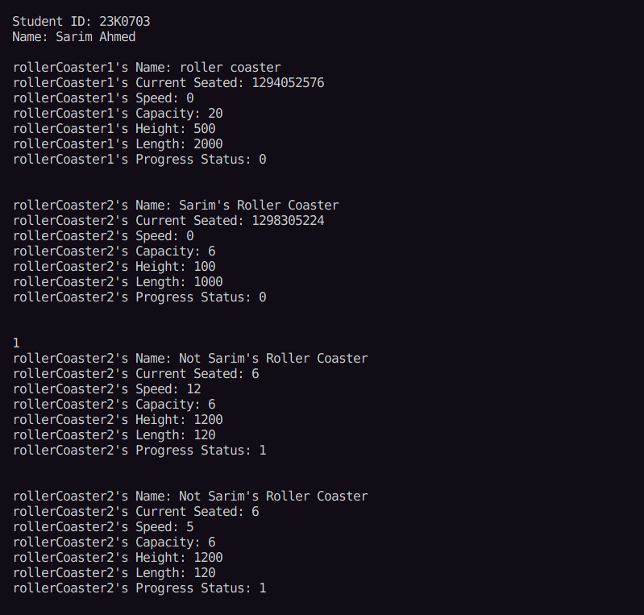

**Question 5:**

Your task is to create a platform dedicated to connecting users with exciting BOGO (Buy One Get One)

deals offered by restaurants. This platform will make it effortless for people to discover and enjoy special

offers from various restaurants, allowing them to savor delicious meals with the added bonus of getting

another one for free.

Restaurant Class encapsulates key details and functionalities related to each restaurant. Features include:

restaurant_name, location, menu_list, price_list, valid_coupon_codes_list, and coupons_redeemed_count

(static variable),a static variable tracking the total number of coupons redeemed across all instances of the

Restaurant class.

Restaurant class must have following member functions:

●

●

●

display_menu()

generate_bill()

apply_discount()BOGOCoupon Class includes features related to coupons such as:

●

●

●

●

coupon_code: Alphanumeric code representing the unique identity of each coupon.

valid_from: The start date when the coupon becomes active.

valid_until: The expiration date marking the end of the coupon's validity.

restaurant_code: The prefix indicating the associated restaurant.

It must have the is_valid Method which validates whether the coupon is within its validity period. Also

checks if the coupon is associated with the selected restaurant.

User Class must have the following attributes name, age, mobile_number, coupons_list: A list containing

the BOGO coupons accumulated by the user, and redeemed_coupons_list.

It must have the following member functions:

●

●

●

Accumulate_coupon(): Adds a new coupon to the user's list, acquired through various activities or

promotions.

Has_valid_coupon(): Checks if the user has a valid unredeemed coupon for a specific restaurant

and item.

redeem_coupon(): Validates the coupon code and ensures it hasn't been previously redeemed.

Main Details:

Two restaurants, namely Food Haven and Pixel Bites, are established with distinctive characteristics. Food

Haven, located in the City Center, offers a fusion of delightful dishes such as Sushi, Pad Thai, and Mango

Tango. On the other hand, Pixel Bites, situated in Cyber Street, entices users with its Digital Delicacies like

Binary Burger, Quantum Quinoa, and Data Donuts.

Users are invited to explore the diverse menu offerings of Food Haven and Pixel Bites through the

display_menu method. BOGO coupons are introduced with restaurant-specific codes. For instance, a

coupon with the code "FH-BOGO-12345" is associated with Food Haven, and another with "PB-BOGO-

67890" is linked to Pixel Bites. When placing an order, users employ the redeem_coupon process. The

system validates the coupon code, ensuring it corresponds to the selected restaurant and has not been

previously redeemed. Successful redemption allows users to enjoy a delightful BOGO offer on their orders,

contributing to a rich and immersive dining experience.

**Code:**

#include <iostream>

#include <cmath>

#include <ctime>

#include <chrono>

using namespace std;

int today[3] = {19, 01, 25};

class BOGOCoupon

{

string couponCode;

int validFrom[3]; *// first element date, second day, third year*

int validUntil[3]; *// first element date, second day, third year*

string restaurantCode;

public:

BOGOCoupon() {}

BOGOCoupon(

string couponCode,

int validFrom[3],

int validUntil[3],

string restaurantCode)

{

this->couponCode = couponCode;

this->restaurantCode = restaurantCode;

for (int i = 0; i < 3; i++)

{

this->validFrom[i] = validFrom[i];

this->validUntil[i] = validUntil[i];

}

}

string get_restaurant_code()

{

return restaurantCode;

}

string get_coupon_code()

{

return couponCode;

}

bool is_valid()

{

int validFromDays = validFrom[0] + (validFrom[1] * 30) + (validFrom[2] * 30 * 12);

int validUntilDays = validUntil[0] + (validUntil[1] * 30) + (validUntil[2] * 30 * 12);

int todayDays = today[0] + (today[1] * 30) + (today[2] * 30 * 12);

*// check if today is after validFrom*

if (todayDays < validFromDays)

{

return false;

}

*// check if today is after validUntil*

if (todayDays > validUntilDays)

{

return false;

}

return true;

}

};

class Restaurant

{

string name;

string location;

string code;

string *menuList;

int numMenuItems;

float *priceList;

string *validCouponCodesList;

int numCouponCodes;

public:

static int redeemedCouponsCount;

Restaurant(string name, string location, string code, string menuList[], float priceList[], int numMenuItems, string validCouponCodesList[], int numCouponCodes)

{

this->name = name;

this->location = location;

this->code = code;

this->numMenuItems = numMenuItems;

this->menuList = new string[numMenuItems];

for (int i = 0; i < numMenuItems; i++)

{

this->menuList[i] = menuList[i];

}

this->priceList = new float[numMenuItems];

for (int i = 0; i < numMenuItems; i++)

{

this->priceList[i] = priceList[i];

}

this->numCouponCodes = numCouponCodes;

this->validCouponCodesList = new string[numCouponCodes];

for (int i = 0; i < numCouponCodes; i++)

{

this->validCouponCodesList[i] = validCouponCodesList[i];

}

}

void displayMenu()

{

cout << "===================" << endl;

cout << " MENU" << endl;

cout << "===================" << endl

<< endl;

cout << "Items\tPrices" << endl;

for (int i = 0; i < numMenuItems; i++)

{

cout << menuList[i] << "\t" << priceList[i] << endl;

}

}

void applyDiscount()

{

cout << "===================" << endl;

cout << " MENU" << endl;

cout << "===================" << endl

<< endl;

cout << "Items\tPrices" << endl;

for (int i = 0; i < numMenuItems; i++)

{

cout << menuList[i] << "\t" << (float)priceList[i] / 2 << endl;

}

}

bool validCoupon(BOGOCoupon couponToCheck)

{

for (int i = 0; i < numCouponCodes; i++)

{

if (couponToCheck.get_coupon_code() == validCouponCodesList[i])

{

return true;

}

}

return false;

}

string getCode()

{

return code;

}

float generateBill(int itemIndex)

{

return priceList[itemIndex];

}

float applyDiscount(float currentBill)

{

*// Halving the price because the average total bill gets half in BOGO*

return currentBill / 2;

}

};

class User

{

string name;

int age;

string mobile_number;

BOGOCoupon coupons_list[20];

int coupons_top;

BOGOCoupon redeemed_coupons_list[20];

int redeemed_coupons_top;

public:

User(string name, int age, string mobile_number)

{

this->name = name;

this->age = age;

this->mobile_number = mobile_number;

coupons_top = -1;

redeemed_coupons_top = -1;

}

void accumulate_coupon(BOGOCoupon coupon)

{

if (coupon.is_valid())

{

coupons_top++;

coupons_list[coupons_top] = coupon;

}

}

int has_valid_coupon(string restaurantCode)

{

for (int i = 0; i <= coupons_top; i++)

{

if (coupons_list[i].is_valid() && coupons_list[i].get_restaurant_code() == restaurantCode)

{

return i;

}

}

return -1;

}

float redeem_coupon(int couponIndex, float currentBill, Restaurant restaurant)

{

cout << restaurant.validCoupon(coupons_list[couponIndex]) << endl;

if (coupons_list[couponIndex].is_valid() && coupons_list[couponIndex].get_restaurant_code() == restaurant.getCode() && restaurant.validCoupon(coupons_list[couponIndex]))

{

Restaurant::redeemedCouponsCount++;

*// Putting current coupon in the redeemed list*

BOGOCoupon couponToMove = coupons_list[couponIndex];

for (int i = couponIndex + 1; i <= coupons_top; i++)

{

coupons_list[i - 1] = coupons_list[i];

}

coupons_list[coupons_top] = BOGOCoupon();

coupons_top--;

redeemed_coupons_top++;

redeemed_coupons_list[redeemed_coupons_top] = couponToMove;

return (float)restaurant.applyDiscount(currentBill);

}

return (float)-1.0;

}

};

int Restaurant::redeemedCouponsCount = 0;

int main()

{

*// Header*

cout << "\n\nStudent ID: 23K0703" << endl;

cout << "Name: Sarim Ahmed" << endl

<< endl;

string foodHavenMenuItems[5] = {

"Sushi",

"Pad",

"Thai",

"Mango",

"Tango",

};

float foodHavenPricesList[5] = {

10.0,

20.0,

30.0,

40.0,

50.0,

};

string foodHavenCoupons[5] = {

"ABCS123421",

"AB56785678",

"ABCF23r2EF",

"ABC65trrrt",

"A234234123",

};

string bytesPixelMenuItems[3] = {

"Binary Burger",

"Quantum Quinoa",

"Data Donuts",

};

float bytesPixelPricesList[3] = {

10.0,

40.0,

50.0,

};

string bytesPixelCoupons[5] = {

"ABCSDFEXEF",

"ABCSXEadsF",

"ABCF23dsdF",

"ABCS2rrer2",

"A234234XEF",

};

Restaurant restaurant1("Food Haven", "City Center", "FH", foodHavenMenuItems, foodHavenPricesList, 5, foodHavenCoupons, 5);

Restaurant restaurant2("Bytes Pixel", "Cyber Street", "BP", bytesPixelMenuItems, bytesPixelPricesList, 3, bytesPixelCoupons, 5);

restaurant1.displayMenu();

User user1("Sarim", 20, "123456789");

int coupon1FromDate[3] = {03, 01, 1};

int coupon1ToDate[3] = {03, 01, 29};

BOGOCoupon coupon1("ABCS123421", coupon1FromDate, coupon1ToDate, "FH");

user1.accumulate_coupon(coupon1);

int validCouponIndex = user1.has_valid_coupon("FH");

float actualBill = restaurant1.generateBill(4);

float discountedBill = user1.redeem_coupon(validCouponIndex, actualBill, restaurant1);

cout << "\n[+] User 1's original bill was Rs." << actualBill << " and it became Rs." << discountedBill << " after discount.";

}

**Output:**

